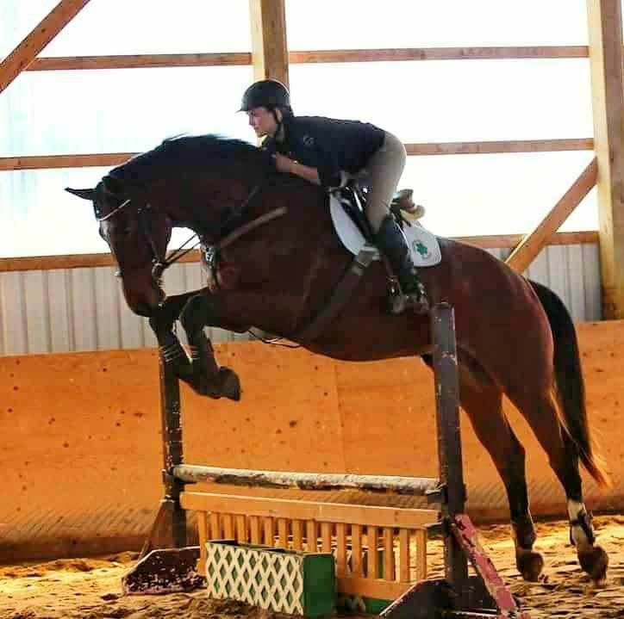  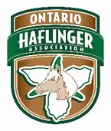  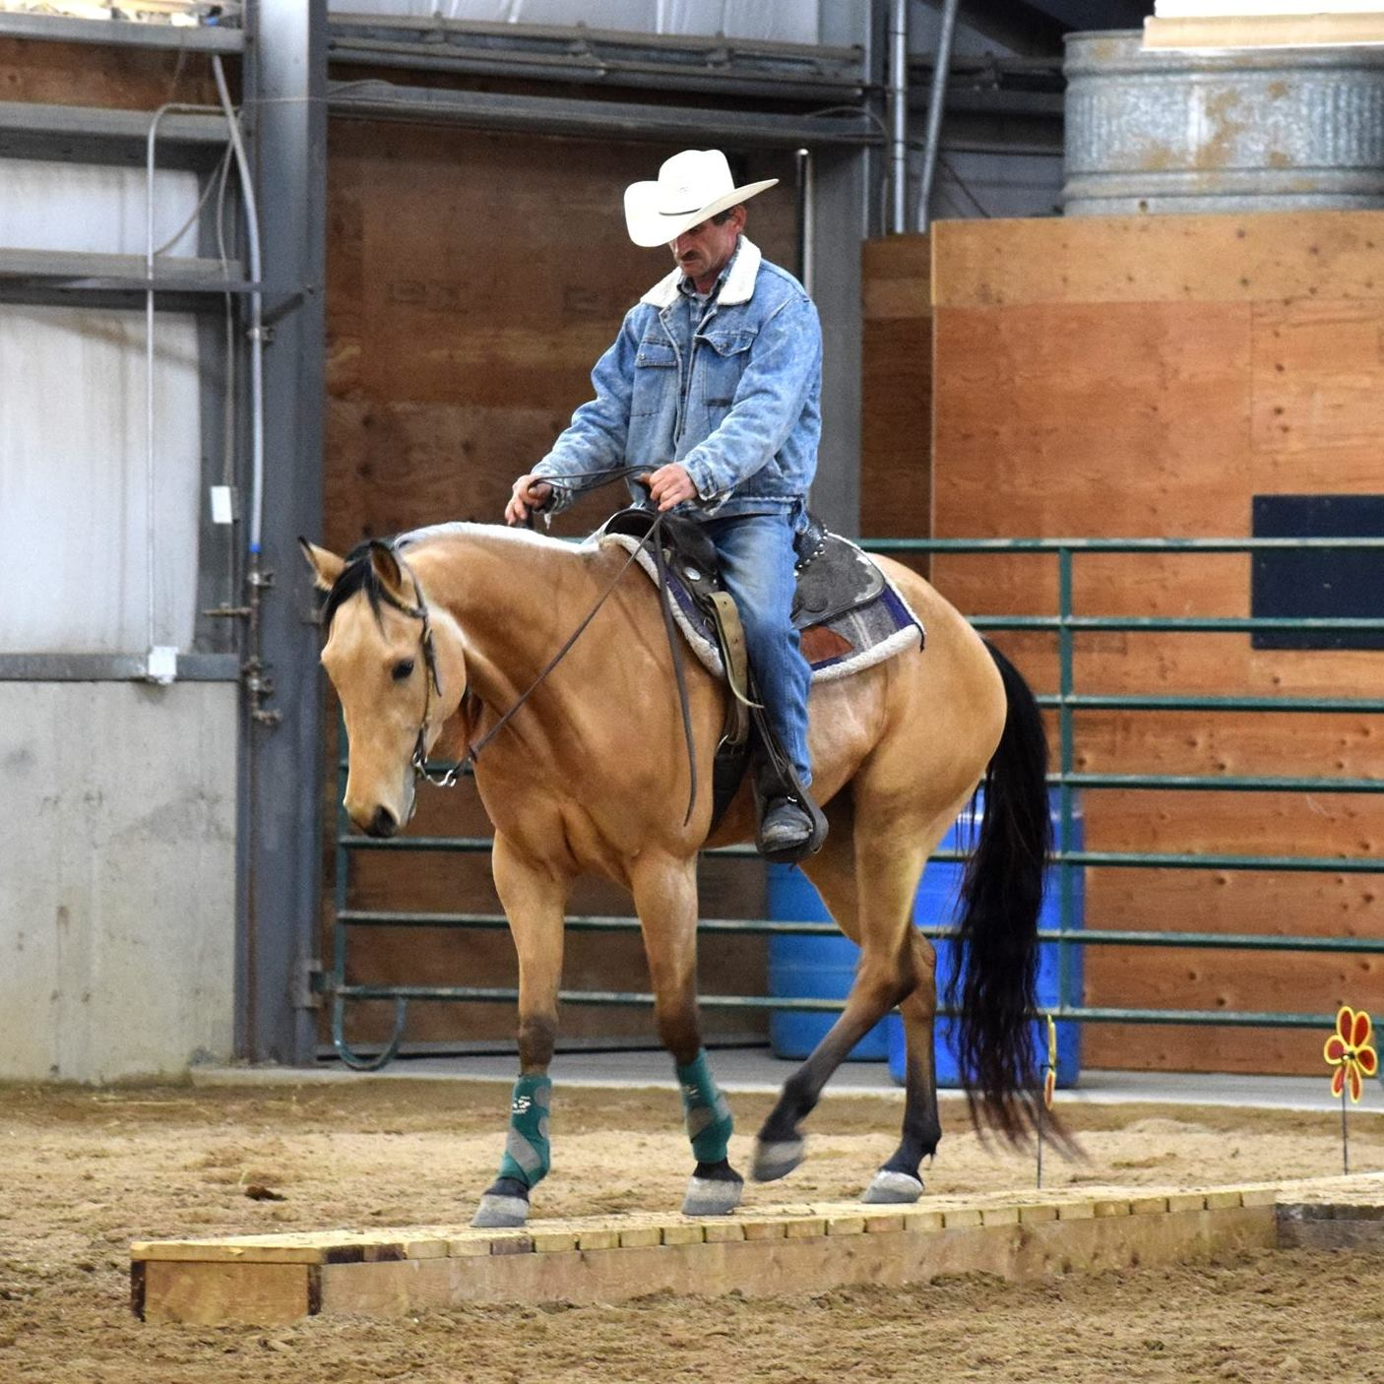  - horsemanship clinic  May 26th 2018 at second chance ranch  Western and English Horsemanship  The Ontario Haflinger Association is hosting an In Hand and Under Saddle Horsemanship Clinic Fundraiser. Our clinicians are seasoned Trainers Dave Black of Diamond B Quarter horses in Selkirk,ON with 30+years, Katie Gaudet CF of Simcoe ON with 17years of experience. Starting the day with “in Hand” work such as basic ground work, respect for space and body movement and moving to “under Saddle” horsemanship after lunch. Working two groups at a time separating English and Western.  In-Hand class starts at 9am sharp to 11:30pm  Lunch from 11:30am-12:30pm  Basic Riding for Beginner Riders 12:30-1:30pm  Under Saddle Horsemanship 1:30pm-4pm  Cost: Adult OHA members are $25/person full day, $15/half day  Youth OHA members are free to participate  Adult Participant $50/person full day, $35 for half day  Youth Participant under 18 yrs $35/person full day, $18/half day  Beginner class flat rate $15/person  Auditors are $10/person and free for OHA members.  Lunch is included to Participants. Participants must have own Liability Insurance (OEF). Youth participants under 18yrs must wear helmets.  Pre-registration and Pre-pay recommended to secure spot. e-tranfer to martina@unitedbuilders.ca or pay cash the day off.  For more info please contact us at grandriverhaffies@outlook.com or on Facebook at Ontario Haflinger Association. Deadline is May20th | Horsemanship clinic Western & English  ____  Where: Second Chance Ranch  ____  When: May 26th 2018  ____  Clinicians: Dave Black of Diamond B Stables & Katie Gaudet CF  ____  In Hand and Under Saddle horsemanship  SCR –Paul & Debbie Gibbons  2217 Old HWY 24  Scotland, ON  N0E1R0  grandriverhaffies@outlook.com  Facebook: Ontario Haflinger Association

